11. Read a CSV File and Display Its Contents

data <- data.frame(x = c(10, 20, 30, 50))
write.csv(data, "students_copy.csv", row.names = FALSE)
data <- read.csv("students_copy.csv")
print("Contents of the CSV file:")
print(data)
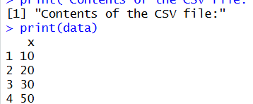

12. Calculate Monthly Averages Using the Airquality Dataset
data("airquality")
result <- aggregate(
cbind(Ozone, Solar.R, Wind, Temp) ~ Month,
data = airquality,
FUN = mean,
na.rm = TRUE
)
print("Monthly average values:")
print(result)
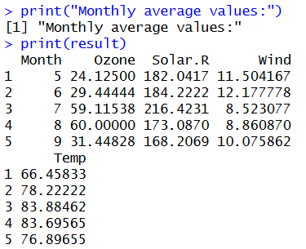
13: Combine Multiple Arrays Row-Wise
a <- c(1, 2, 3)
b <- c(4, 5, 6)
c <- c(7, 8, 9)
d <- rbind(a, b, c)
print("Combined arrays (row-wise):")
print(d)
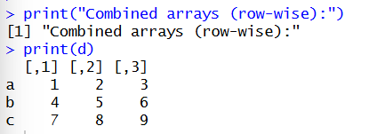

14: Explore and Manipulate the ChickWeight Dataset
data("ChickWeight")
head(ChickWeight)
sorted <- ChickWeight[order(ChickWeight$weight), ]
print("Sorted ChickWeight dataset:")
print(sorted)
print("Average weight by Diet:")
aggregate(weight ~ Diet, data = ChickWeight, FUN = mean)
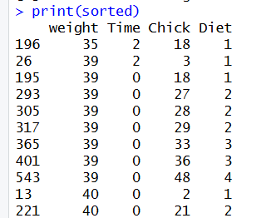
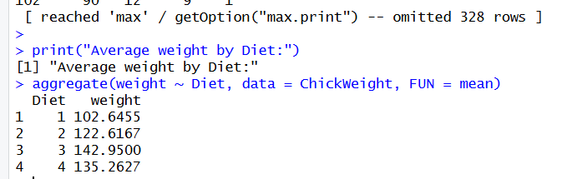

15: Perform EDA on the Iris Dataset

Code
data("iris")
print("Dimensions:")
dim(iris)
print("Summary:")
summary(iris)
print("Standard deviation:")
sapply(iris[, 1:4], sd)
print("Quantiles of Sepal Length:")
quantile(iris$Sepal.Length)
print("Mean values grouped by Species:")
aggregate(. ~ Species, data = iris, FUN = mean)

print("Pivot table:")
table(iris$Species)
iris$Sepal_Category <- cut(
iris$Sepal.Length,
breaks = 3,
labels = c("Short", "Medium", "Long")
)
print("Sepal Length categories:")
table(iris$Sepal_Category)

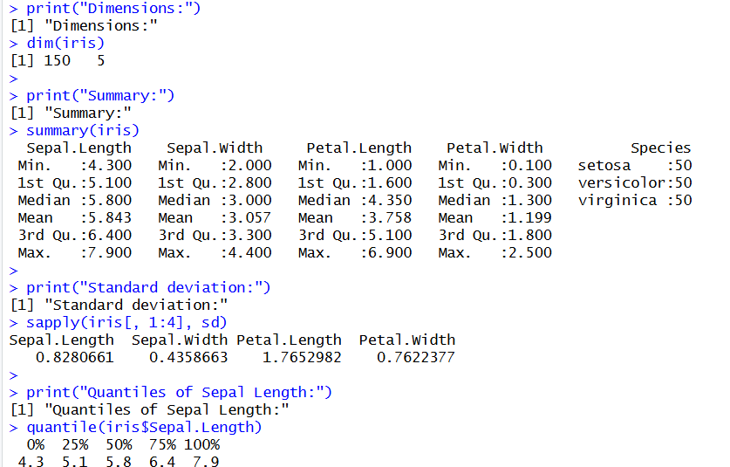

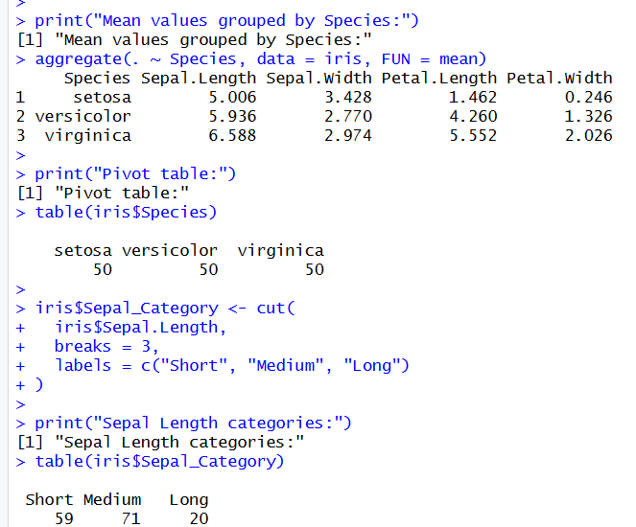
16. Explore USArrests Dataset

CODE;
data(USArrests)
print(summary(USArrests))
print(rownames(USArrests)[which.max(USArrests$Rape)])
print(max(USArrests$Murder))
print(min(USArrests$Murder))
print(cor(USArrests))
median_assault <- median(USArrests$Assault)
q1_murder <- quantile(USArrests$Murder, 0.25)
print(USArrests[
USArrests$Assault > median_assault &
USArrests$Murder <= q1_murder,
])
hist(USArrests$Murder,
main = "Histogram of Murder Rates",
xlab = "Murder")
plot(density(USArrests$Murder),
main = "Density of Murder Rates")
plot(USArrests$Assault, USArrests$Murder,
main = "Assault vs Murder",
xlab = "Assault",
ylab = "Murder")

barplot(USArrests$Murder,
names.arg = rownames(USArrests),
las = 2,
cex.names = 0.5,
main = "Murder Rates by State")
OUTPUT:

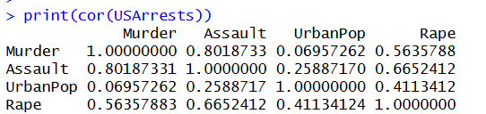
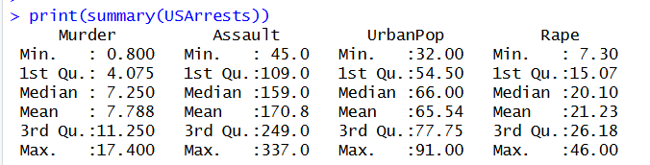
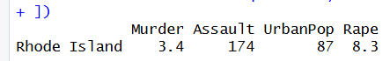

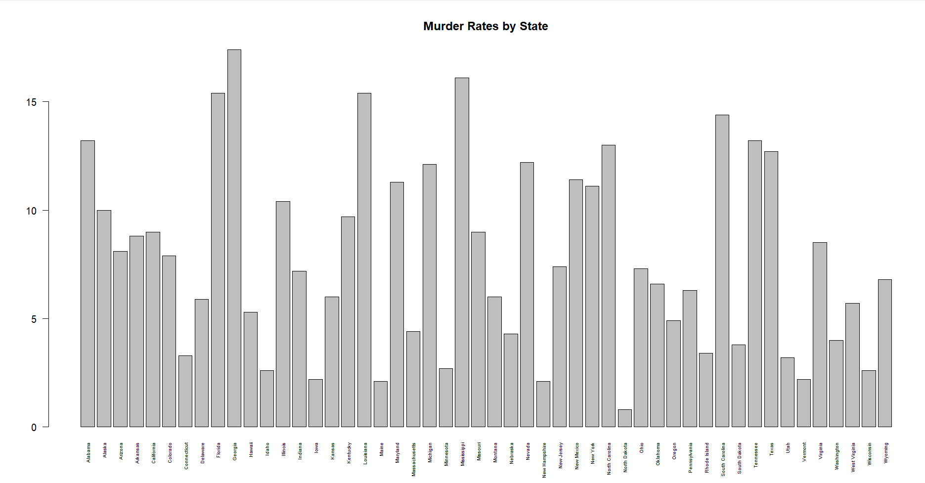

17. Explore Titanic Dataset
data(Titanic)

titanic_data <- as.data.frame(Titanic)

survival_class <- xtabs(
Freq ~ Class + Survived,
data = titanic_data
)
barplot(t(survival_class),
beside = TRUE,
legend = TRUE,
main = "Survival vs Class",
xlab = "Passenger Class",
ylab = "Frequency")
survival_gender <- xtabs(
Freq ~ Sex + Survived,
data = titanic_data
)

barplot(t(survival_gender),
beside = TRUE,
legend = TRUE,
main = "Survival vs Gender",
xlab = "Gender",
ylab = "Frequency")
OUTPUT

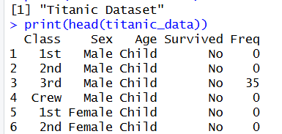
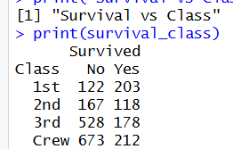
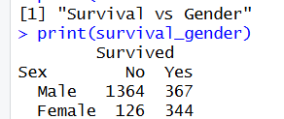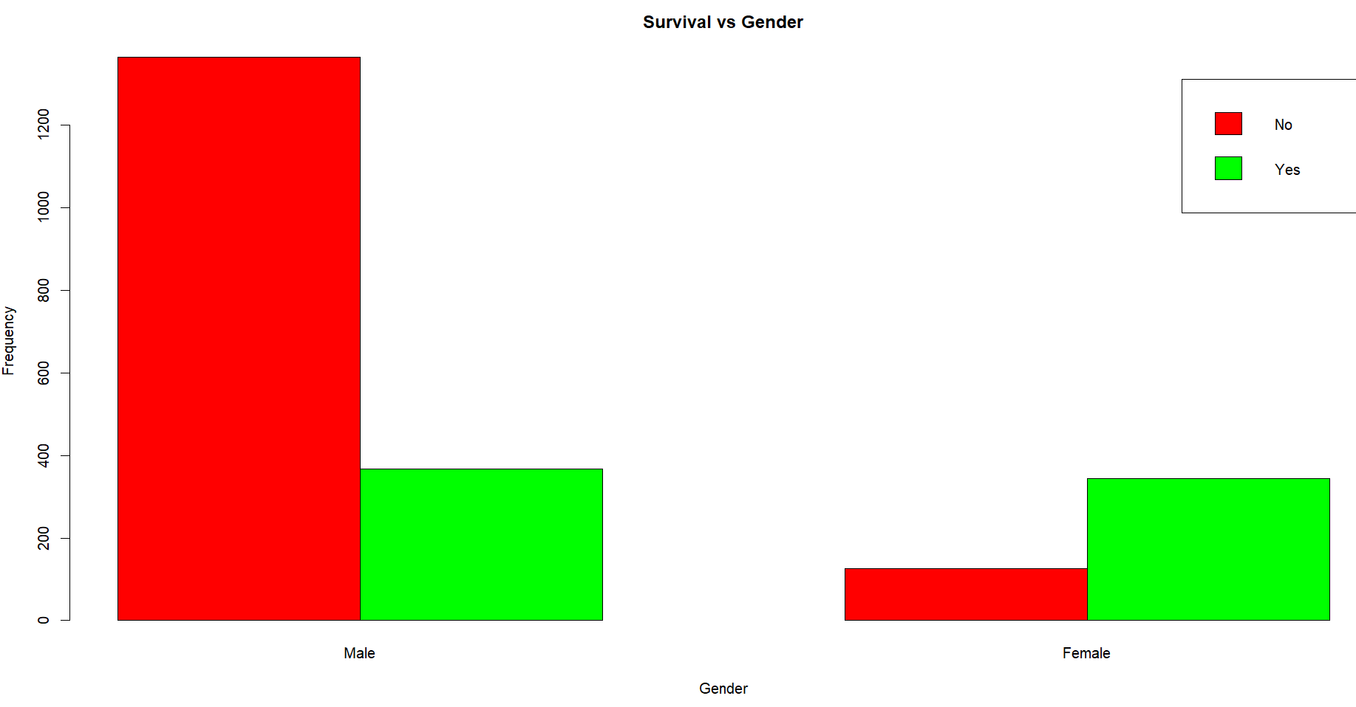

Question 18: Create Graphs in R
CODE:
x <- c(10, 20, 30, 40, 50)
y <- c(15, 25, 20, 35, 45)

par(mfrow = c(2, 3))

boxplot(x, main = "Boxplot",
col = "lightblue")

hist(x, main = "Histogram",
xlab = "Values",
col = "lightgreen")

barplot(x, names.arg = 1:5,
main = "Bar Plot",
col = "orange")

plot(x, type = "l",
main = "Line Chart",
xlab = "Index",
ylab = "Values",
col = "blue")

plot(x, y,
main = "Scatter Plot",
xlab = "X Values",
ylab = "Y Values",
pch = 19,
col = "red")

plot.new()
title("Five Graphs in R")

par(mfrow = c(1, 1))
OUTPUT:

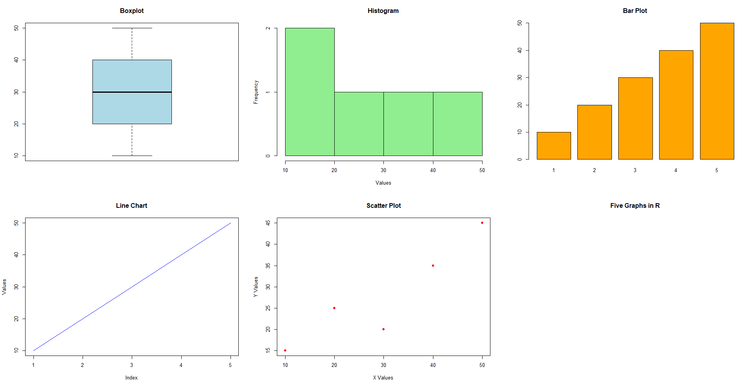
Question 19: Build a Regression Model on Advertising Dataset
CODE:
Spend <- c(10, 20, 30, 40, 50, 60, 70, 80)
Sales <- c(15, 25, 28, 40, 45, 55, 60, 75)

advertising <- data.frame(Spend, Sales)

model <- lm(Sales ~ Spend, data = advertising)
print(summary(model))

new_data <- data.frame(Spend = 90)
predicted_sales <- predict(model, newdata = new_data)
cat("Predicted Sales:", predicted_sales, "\n")
plot(Spend, Sales,
main = "Advertising Spend vs Sales",
xlab = "Spend",
ylab = "Sales",
pch = 19)
abline(model, col = "red")
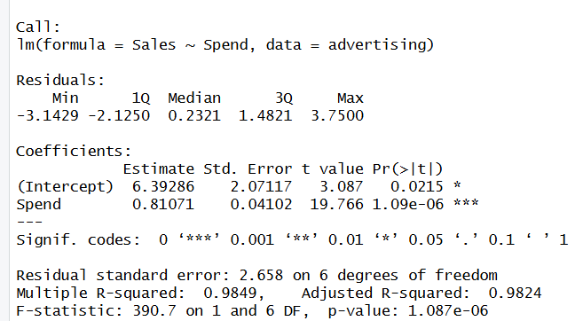
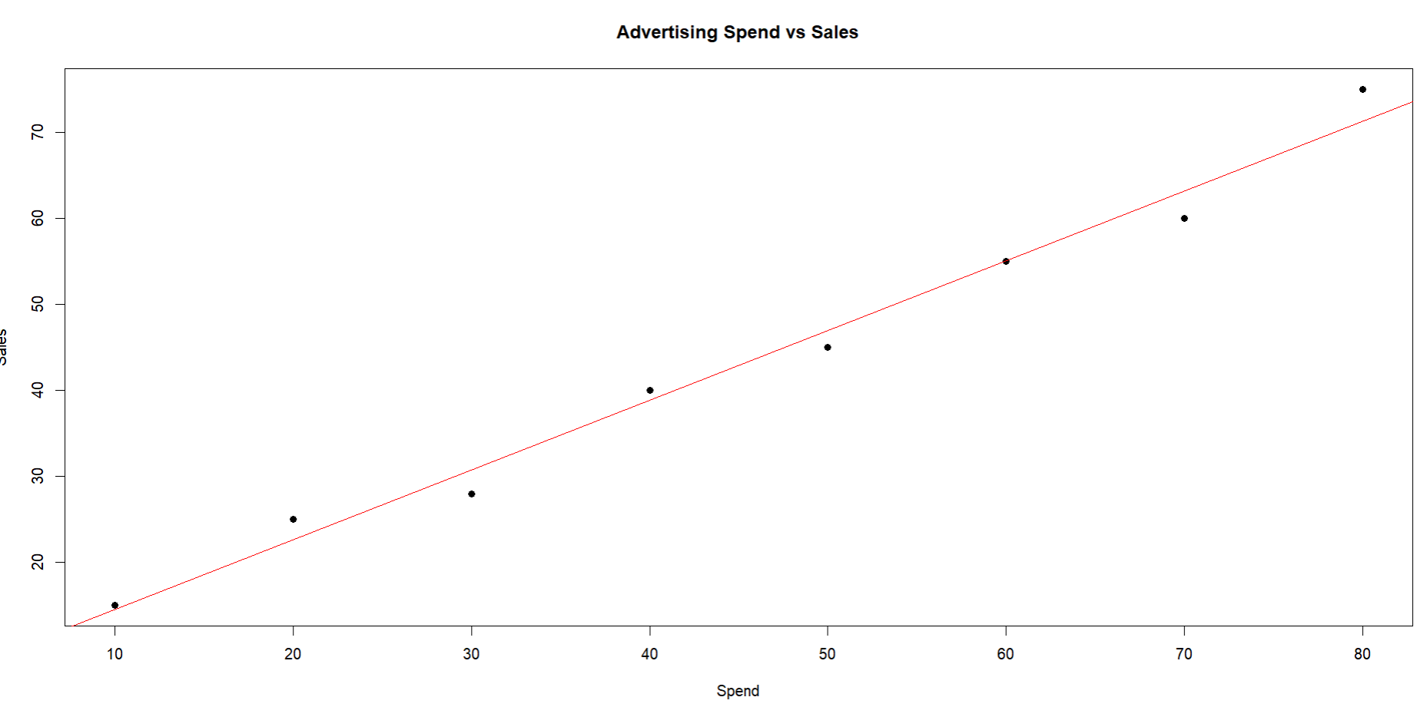


Question 20: Multiple Regression Using ChickWeight Dataset
CODE:
data(ChickWeight)
model <- lm(weight ~ Time + Diet, data = ChickWeight)
print(summary(model))
predicted_weight <- predict(model, newdata = ChickWeight)
cat("First 10 Predicted Weights:\n")
print(head(predicted_weight, 10))
actual_weight <- ChickWeight$weight
mse <- mean((actual_weight - predicted_weight)^2)
cat("Mean Squared Error:", mse, "\n")
OUTPUT:
